SCHOOL OF COMPUTING AND INFORMATICS
DEPARTMENT OF INFORMATION TECHNOLOGY

Name: ALLAN MWAURA
Reg: BSCCS/2024/59744
Repo: https://github.com/spookey01/CRYPT.git
Lecturer: Michael Nyoro

This project is submitted in partial fulfillment of requirement for the Mount Kenya University award of
BACHELOR OF SCIENCE IN COMPUTER SCIENCE
MAY/AUG 2026

Table of Contents
Encrypt “SECURITY” using Caesar Cipher with shift 4. 3
Weakness Identification 5
Caesar Cipher Weaknesses 5
Vigenère Cipher Weaknesses 5
Python Random Numbers 6
Linear Congruential Generator 7

Encrypt “SECURITY” using Caesar Cipher with shift 4.
Encrypted text: WIGYVMXC
- Encrypt “NETWORK” using Vigenère Cipher using keyword “KEY”.
Encrypted text: XIRGSPU
- Exchange encrypted messages and attempt decryption.
Encrypted message: YMNX NX F YJXY
- Cipher used: Caesar Cipher (Shift = 5)
- Recovered plaintext: THIS IS A TEST
Feature | Caesar Cipher | Vigenère Cipher
Method | Fixed shift | Keyword-based shifts
Key | Single number | Word/phrase
Security | Weak | Moderate
Advantages | Simple, fast | More secure
Weaknesses | Easily cracked | More complex
Implementation | Very easy | Moderate


Screenshot of an online classical cipher simulation

Weakness Identification

Caesar Cipher Weaknesses
- Only 25 possible keys → easy brute force
- Preserves letter patterns
- Very easy frequency analysis attack
- Not secure at all in modern cryptography

Vigenère Cipher Weaknesses
- Repeating keyword creates pattern repetition
- Can be broken using:
  - Frequency analysis
  - Kasiski examination (key length detection)
- Weak if keyword is short or simple

Python Random Numbers
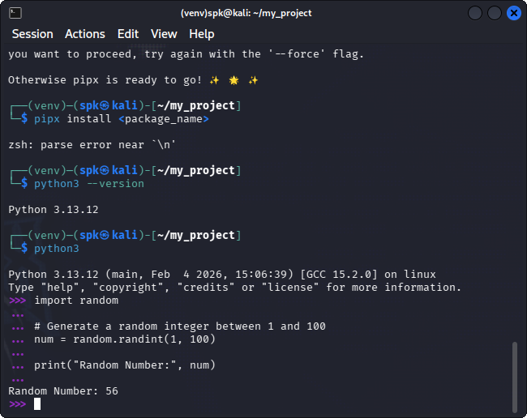

Linear Congruential Generator
